<Hotel Website>

Software Requirements Specification

<1.0>

<3/11/2024>

Prepared by

<Eng. Mohammed>

<Eng. Gamal >

<Eng. Abdelrhman>

<Eng. Ziad>

<Eng. Menna>

<Eng. Malak>

<Eng. Asmaa >

<Eng. Marwan>

# Revision History

|  |  |  |  |
| --- | --- | --- | --- |
| **Date** | **Description** | **Author** | **Comments** |
| <date> | <Version 1> | <Your Name> | <First Revision> |
|  |  |  |  |
|  |  |  |  |
|  |  |  |  |

# Document Approval

The following Software Requirements Specification has been accepted and approved by the following:

|  |  |  |  |
| --- | --- | --- | --- |
| **Signature** | **Printed Name** | **Title** | **Date** |
|  | <Your Name> | <Title> |  |
|  |  |  |  |
|  |  |  |  |

**Table of Contents**

Revision History ii

Document Approval ii

1. Introduction 1

1.1 Purpose 1

1.2 Scope 1

1.3 Definitions, Acronyms, and Abbreviations 1

1.4 References 1

1.5 Overview 1

2. General Description 2

2.1 Product Perspective 2

2.2 Product Functions 2

2.3 User Characteristics 2

2.4 General Constraints 2

2.5 Assumptions and Dependencies 2

3. Specific Requirements 2

3.1 External Interface Requirements 3

3.1.1 User Interfaces 3

3.1.2 Software Interfaces 3

3.1.3 Communications Interfaces 3

3.2 Functional Requirements 3

3.2.1 User Account Management 3

3.2.2 Room Booking System 3

3.2.3 Payment System 3

3.3 Use Cases 3

3.3.1 Use Case #1 3

3.3.2 Use Case #2 3

3.4 Non-Functional Requirements 4

3.4.1 Performance 4

3.4.2 Reliability 4

3.4.3 Security 4

3.4.4 Maintainability 4

3.5 Design Constraints 4

3.6 Logical Database Requirements 4

4. Analysis Models 4

4.1 Sequence Diagrams 5

4.3 Data Flow Diagrams (DFD) 5

4.2 State-Transition Diagrams (STD) 5

5. Change Management Process 5

A. Appendices 5

A.1 Appendix 1 5

A.2 Appendix 2 5

# 1. Introduction

## 1.1 Purpose

The purpose of this SRS is to define the requirements for a hotel website that provides a user-friendly interface for users to view hotel information, create accounts, make room bookings, and handle reservations. This document is intended for the development team, stakeholders, and other project contributors.

## 1.2 Scope

The website is intended to offer:

1. An overview of the hotel, including services, payment methods, and reservation options.

2. A user account system with registration and login capabilities.

3. A booking system that allows users to reserve and cancel rooms.

## 1.3 Definitions, Acronyms, and Abbreviations

* **UX (User Experience)**  
  The overall experience a user has when interacting with the website. It covers factors like usability, navigation, accessibility, and how easy it is to accomplish tasks such as booking a room.
* **UI (User Interface)**  
  The visual elements of the website—what the user interacts with, such as buttons, forms, images, and layout. UI design focuses on making the website easy to use and aesthetically pleasing.
* Booking Engine  
  A tool or software integrated into the website that allows guests to make reservations directly from the hotel’s website. This system processes availability, rates, and payment.
* **Booking Confirmation Page**   
  The page displayed after a user completes a booking, confirming the reservation details such as dates, room type, price, and confirmation number.
* **API (Application Programming Interface)**  
  A set of protocols and tools for building software applications. It allows different systems (like a hotel’s booking engine and PMS) to communicate with each other.
* **B2C (Business to Consumer)**  
  refers to the transaction model where businesses (hotels) sell directly to consumers (guests). Most hotel websites follow a B2C model, allowing guests to book directly.
* **B2B (Business to Business)**  
  Refers to transactions between businesses. In the hotel industry, B2B might involve partnerships with travel agents, tour operators, or corporate clients for group bookings.

## 1.4 References

-Hotel Branding Guidelines Document

• Description: A document detailing the hotel's branding elements, such as logo, color schemes, typography, and imagery guidelines.

• Purpose: Used to ensure design alignment with the hotel’s established brand identity, helping create a cohesive look and feel across the website.

• Location: [Provide link or repository location if available].

-Industry-Standard UX and UI Guidelines for Responsive Web Design

• Description: Guidelines for creating user interfaces that adapt well to different screen sizes, including best practices for navigation, layout, and accessibility.

• Purpose: Ensures that the website is intuitive and fully functional on various devices, such as desktops, tablets, and smartphones.

• Source: [Specify any particular standards body or source, e.g., W3C for web accessibility standards, if applicable].

## 1.5 Overview

This SRS document details the functional and non-functional requirements for the website, the specific features it will provide, and the constraints under which it will operate.

# 2. General Description

## 2.1 Product Perspective

The hotel website will serve as a standalone platform and primary online presence, designed to attract potential guests by offering an easy-to-navigate, visually appealing, and informative experience, allowing guests to view, book, and manage reservations with payment processing.

## 2.2 Product Functions

The website will offer the following key functions:

### 2.2.1 User Account Management: Account creation, login, and profile management.

### 2.2.2 Room Booking System: Functionality to browse rooms, view availability, book, and cancel reservations .

### 2.2.3 Hotel Overview: Information on hotel services, payment options, and reservation processes.

### 2.2.4 Contact and Support: Contact forms, and FAQ.

## 2.3 User Characteristics

### 2.3.1 Guests: Individuals looking to book rooms or inquire about the hotel

### 2.3.2 Hotel Staff: Authorized staff may require backend access to manage content, bookings, and customer queries.

## 2.4 General Constraints

- The website must be accessible on desktop, tablet, and mobile devices.

- The design must align with the hotel's branding.

## 2.5 Assumptions and Dependencies

- It is assumed that a payment gateway (e.g., Master Card) will be integrated for online bookings.

- The website is expected to interface with a backend reservation system.

---

# 3. Specific Requirements

## 3.1 External Interface Requirements

### 3.1.1 User Interfaces

- Navigation: Clean and simple navigation bar with sections for hotel overview, booking, account, and contact.

- Booking Page: An intuitive interface with a calendar view to select dates, available rooms, and prices.

- Responsive Design: Must be fully functional on all devices and screen sizes.

### 3.1.2 Software Interfaces

- Integration with payment gateway and a backend system for room availability and reservation.

### 3.1.3 Communications Interfaces

- The website may support email notifications for booking confirmations and cancellations.

## 3.2 Functional Requirements

### 3.2.1 User Account Management

1. Registration: Users can create an account by providing personal information.

2. Login: Registered users can log in to view their booking history.

3. Profile Management: Users can update their personal information.

### 3.2.2 Room Booking System

1. Room Browsing: Users can view available rooms, features, and prices.

2. Booking Functionality: Users can select dates, view available rooms, and confirm bookings with payment.

3. Cancellation: Users can cancel reservations and receive a confirmation.

### 3.2.3 Payment System

1. Payment Options: Provide a secure payment gateway for credit card and online payments.

2. Refund Processing: Handle refund requests for cancellations.

…

## 3.3 Use Cases

### 3.3.1 Use Case #1.

|  |  |
| --- | --- |
| Use case name | Sign In |
| Trigger | The user wants to log into the system |
| Preconditions | 🡪 The user has a registered account.  🡪 The system is online and accessible. |
| Basic Flow | 1- The user navigates to the Sign-In page.  2- The user enters their email and password.  3- The system checks the credentials against the User Database.  4- If valid, the system grants access to the Home page. |
| Postconditions | The user is logged into the system and directed to the Home page. |
| Alternate Flow | * **Invalid Credentials**: If the credentials are incorrect, the system displays an error message and prompts the user to re-enter their login information. |

### 3.3.2 Use Case #2:

|  |  |
| --- | --- |
| Use case name | Sign Up |
| Trigger | The user wants to create a new account in the system. |
| Preconditions | 🡪 The user does not have an existing account.  🡪 The system is online and accessible. |
| Basic Flow | 1. The user navigates to the Sign-Up page. 2. The user enters their personal details, including name, email, and password. 3. The system validates the information. 4. The system saves the user's information in the User Database. 5. The system confirms the successful registration to the user.   • |
| Postconditions | 🡪 The user account is created and stored in the User Database.  🡪 The user can now log in to the system. |
| Alternate Flow | **Invalid Information**: If the user enters invalid information (e.g., missing fields), the system shows an error message and prompts the user to correct the details. |

### 3.3.3 Use Case #3:

|  |  |
| --- | --- |
| Use case name | View Profile |
| Trigger | The user wants to view or update their profile information |
| Preconditions | 🡪The user is logged into the system |
| Basic Flow | 1. The user selects the "View Profile" option from the Home page. 2. The system retrieves the user's information from the User Database. 3. The user reviews and, if desired, updates their information. 4. The system saves any updates to the User Database. |
| Postconditions | The user's profile information is up-to-date in the User Database. |
| Alternate Flow | **No Updates**: If the user does not make any updates, the system simply displays the profile information without changes. |

### 

### 3.3.4 Use Case #4:

|  |  |
| --- | --- |
| Use case name | **View Available Rooms** |
| Trigger | The user wants to see which rooms are available for booking. |
| Preconditions | 🡪 The user is logged into the system.  🡪 There are rooms available for booking in the Rooms Database. |
| Basic Flow | 1- The user selects "View Available Rooms" from the Home page.  2- The system retrieves a list of available rooms from the Rooms Database.  3- The user views the list of available rooms. |
| Postconditions | 🡪The user can proceed with booking if a suitable room is found. |
| Alternate Flow | **No Available Rooms**: If no rooms are available, the system displays a message indicating that no rooms are currently available for booking. |

### 3.3.5 Use Case #5:

|  |  |
| --- | --- |
| Use case name | Booking |
| Trigger | The user decides to book a room |
| Preconditions | 🡪 The user is logged into the system.  🡪 The user has selected an available room from the list. |
| Basic Flow | 1- The user selects a room from the available options.  2- The system marks the room as "Booked" in the Rooms Database.  3- The system prompts the user to proceed to payment. |
| Postconditions | 🡪The selected room is reserved for the user in the Rooms Database. |
| Alternate Flow | **Room Unavailable**: If the selected room becomes unavailable before booking, the system informs the user and refreshes the list of available rooms. |

### 3.3.6 Use Case #6:

|  |  |
| --- | --- |
| Use case name | Paying |
| Trigger | The user is ready to make a payment to confirm their booking |
| Preconditions | 🡪The user has selected a room and initiated the booking process. |
| Basic Flow | 1- The user is prompted to enter payment information.  2- The system processes the payment.  3- The system updates the History Database with the booking and payment details.  4- The system confirms the successful payment to the user. |
| Postconditions | 🡪The booking is confirmed, and payment details are stored in the History Database. |
| Alternate Flow | **Payment Failure**: If the payment fails, the system notifies the user and prompts them to try another payment method. |

### 3.3.7 Use Case #7:

|  |  |
| --- | --- |
| Use case name | **Cancel Booking** |
| Trigger | The user wants to cancel a booking |
| Preconditions | 🡪The user has an existing booking. |
| Basic Flow | 1- The user submits a cancellation request from the Home page.  2- The system forwards the cancellation request to the staff for approval.  3- The system notifies the user that the cancellation request has been sent. |
| Postconditions | The cancellation request is pending staff approval. |
| Alternate Flow | **Immediate Cancellation**: If the system allows immediate cancellations (without staff approval), the system cancels the booking and updates the room status to available. |

### 3.3.8 Use Case #8:

|  |  |
| --- | --- |
| Use case name | Accept Cancellation |
| Trigger | The staff reviews and approves a user’s cancellation request. |
| Preconditions | 🡪 A cancellation request has been submitted by the user.  🡪 The staff is authorized to approve cancellations |
| Basic Flow | 1- The staff accesses the pending cancellation requests.  2- The staff approves the cancellation request.  3- The system updates the History Database to mark the booking as "Canceled."  4- The system updates the Rooms Database to make the room available again.  5- The system notifies the user of the successful cancellation. |
| Postconditions | 🡪 The room becomes available for future bookings.  🡪 The booking history reflects the cancellation status |
| Alternate Flow | **Request Denial**: If the staff denies the cancellation request, the user is notified, and the booking remains unchanged. |

…

## 

## 3.4 Non-Functional Requirements

### 3.4.1 Performance: Pages must load within few seconds on standard internet connections.

### 3.4.2 Reliability: Booking functionality should be available most of the time.

### 3.4.3 Security: Ensure secure transactions, account security, and data protection.

### 3.4.4 Maintainability: The website’s content management system should allow easy updates.

## 3.5 Design Constraints

The website design must adhere to hotel branding, including colors, logos, and imagery that convey the hotel’s unique ambiance.

## 3.6 Logical Database Requirements

1. User Data: Store user profiles, booking history, and payment details securely.

2. Room Data: Track room types, availability, and pricing.

3.Hotel Staff Data:Store staff profiles.

---

# 4. Analysis Models

## 4.1 Sequence Diagrams

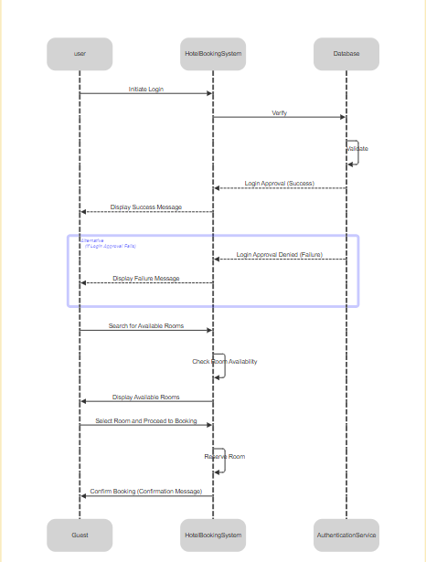

## 4.2 Data Flow Diagrams (DFD)

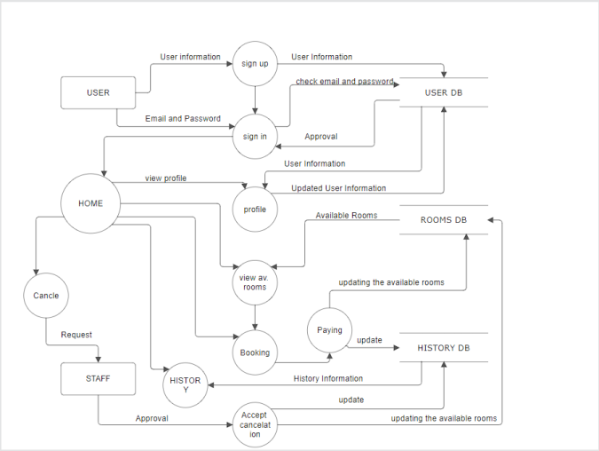

## 4.3 State-Transition Diagrams (STD)

# 

# 5. Change Management Process

All changes to this SRS must be submitted in writing and approved by project stakeholders. Minor updates can be approved by the lead software engineer, while major changes require stakeholder review.

---

A. Appendices

A.1 Sample meeting notes and design guidelines

**1. Sample Meeting Notes**

**Meeting Objective**: Discuss development goals and features for the hotel website.  
**Participants**: Development team, project manager, and hotel representatives  
**Meeting Summary**:

* **Room Booking System**: Emphasis on a user-friendly interface for viewing and booking rooms, as well as easy reservation cancellation options.
* **User Interface (UI)**: Requirement for a simple, intuitive navigation that makes main sections easily accessible (account registration, booking, support).
* **Security and Payment**: Integration of a secure payment gateway and a clear process for handling refund requests on cancellations.
* **Design Standards**: Agreement on design elements that align with the hotel's branding, such as color schemes and typography.

**2. Design Guidelines**

Since the website should match the hotel’s brand identity, design guidelines include:

* **Color Scheme**: Consistent use of colors specified in the hotel’s branding guidelines.
* **Visuals**: High-quality images reflecting the ambiance of the hotel, such as suites, dining areas, and amenities.
* **Responsive Design**: Ensure that the design works smoothly on all devices (desktop, tablet, mobile).
* **Content Layout**: Use clear fonts for readability, with straightforward, uncluttered page layouts.

A.2 Relevant marketing materials for the website

**1. Online Advertisements**

**Description**: Sample advertisements for social media platforms, such as Facebook and Instagram, to promote the website.  
**Content**:

* **Hotel Room Images**: High-quality images of rooms and amenities to convey a unique experience.
* **Special Offers**: Graphics and promotional text for deals, such as discounts on extended stays or complimentary breakfasts.

**2. Marketing Copy**

Brief promotional texts for the website, showcasing key hotel features, services, and payment policies. These materials should convey the hotel’s unique offerings, create a welcoming tone for guests, and encourage direct bookings.

---